Network Scanning Tools (Windows & macOS)

Introduction
Network scanning is an essential phase in cybersecurity used to identify live hosts, open ports, and services in a network. As discussed in CEH Module 03, scanning tools help security professionals gather information about a target system for analysis and defense .
In this document, we explore some easy-to-use tools that can be demonstrated in class on Windows and macOS.
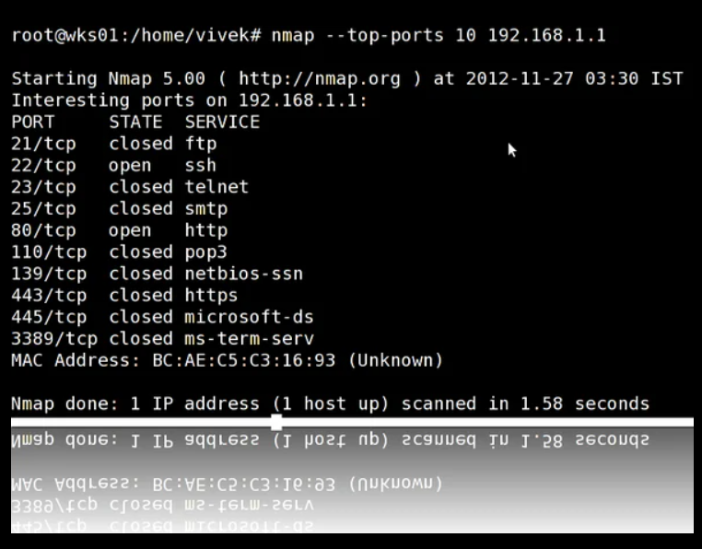
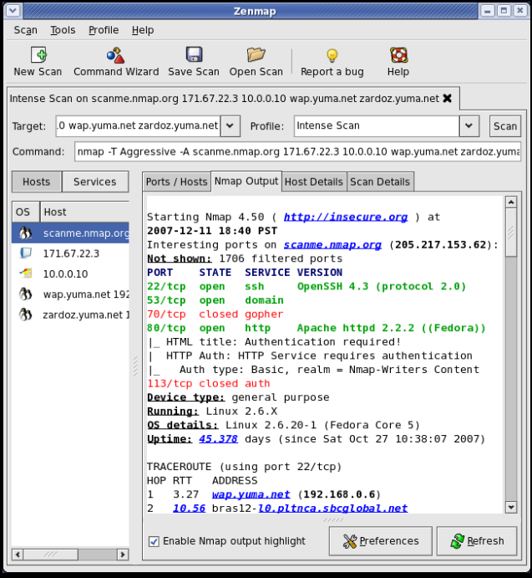
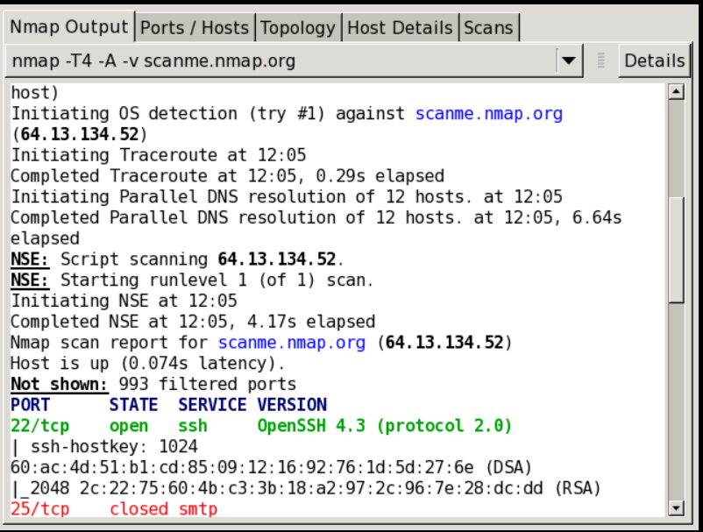
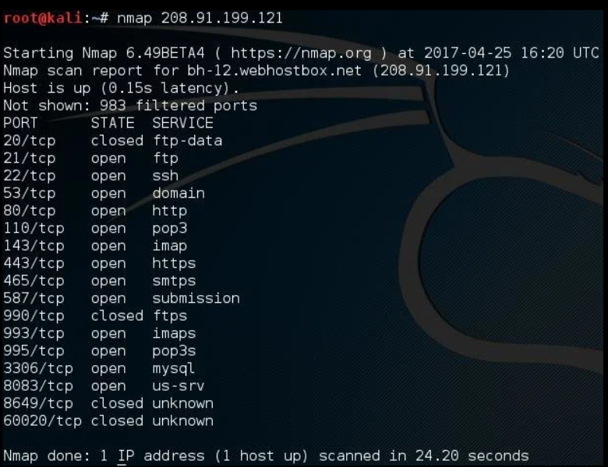

📖 Description
Nmap is one of the most powerful and widely used network scanning tools. It is used to discover hosts, open ports, services, and even operating systems on a network.

💻 Supported Platforms
- Windows
- macOS
- Linux

⚙️ Key Features
- Host discovery
- Port scanning (TCP/UDP)
- OS detection
- Service/version detection

🧪 Example Commands
nmap 192.168.1.1
nmap -sS -A 192.168.1.0/24

🎓 Classroom Use
- basic scanning with GUI (Zenmap)
- advanced scanning using command line
Nmap Commands for Single IP
• Basic Scan: nmap 192.168.1.1 (Scans top 1,000 TCP ports)
• Aggressive Scan: nmap -A -T4 192.168.1.1 (OS detection, version detection, script scanning, and traceroute)
• Scan Specific Ports: nmap -p 80,443,22 192.168.1.1
• Scan All 65535 Ports: nmap -p- 192.168.1.1
• Fast Scan (Top 100 Ports): nmap -F 192.168.1.1
• Detect Service Version: nmap -sV 192.168.1.1
• Ping Scan (Host Discovery): nmap -sn 192.168.1.1

Nmap Commands for Networks

• Scan a Subnet (CIDR): nmap 192.168.1.0/24
• Scan an IP Range: nmap 192.168.1.1-50
• Scan Entire Subnet (Wildcard): nmap 192.168.1.*
• Host Discovery on Network: nmap -sn 192.168.1.0/24 (Lists active hosts)
• Fast Network Scan: nmap -F 192.168.1.0/24
• Exclude Hosts: nmap 192.168.1.0/24 --exclude 192.168.1.1

2. Angry IP Scanner

📖 Description
Angry IP Scanner is a fast and simple tool used to scan IP addresses and detect active devices on a network.

💻 Supported Platforms
- Windows
- macOS
- Linux

⚙️ Key Features
- Scans IP ranges quickly
- Identifies live hosts
- Displays hostname and open ports

🎓 Classroom Use
- Best for beginners
- Simple “enter range → scan” demonstration
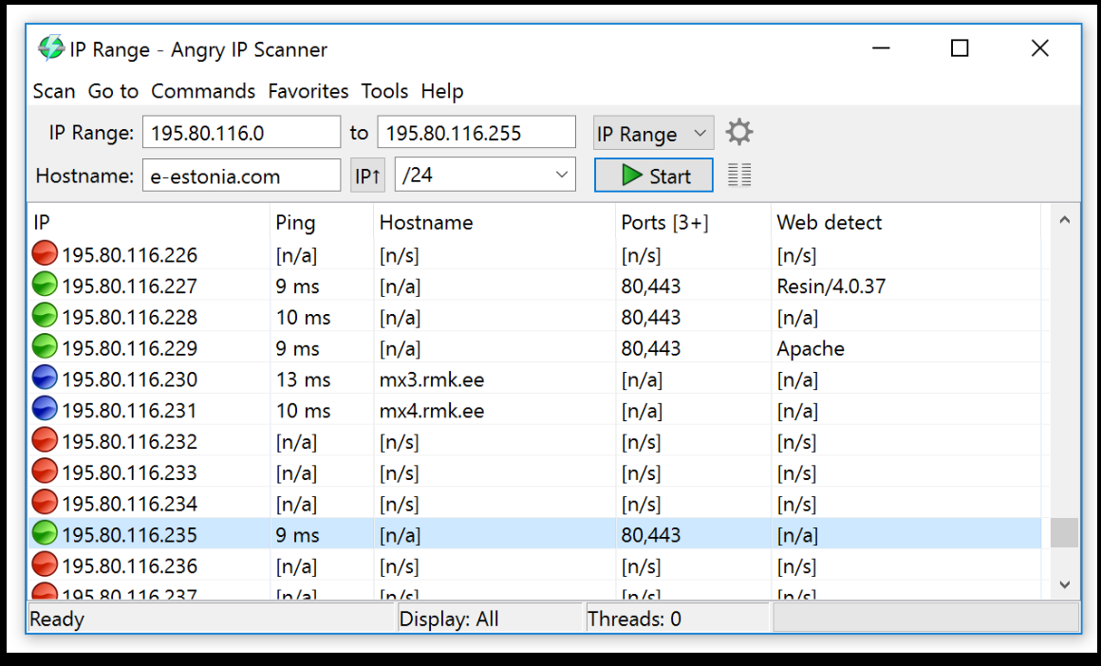
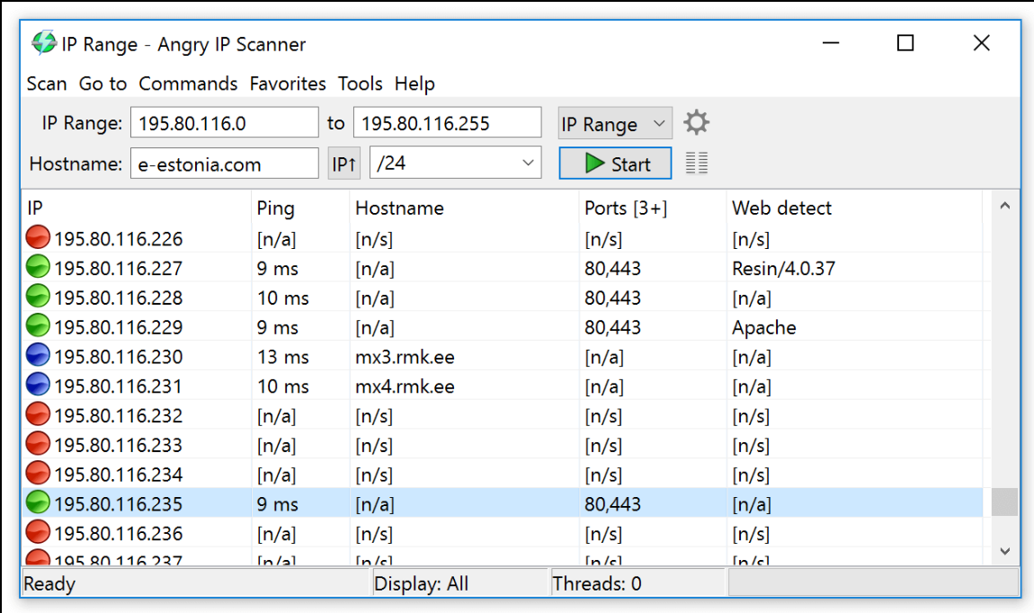
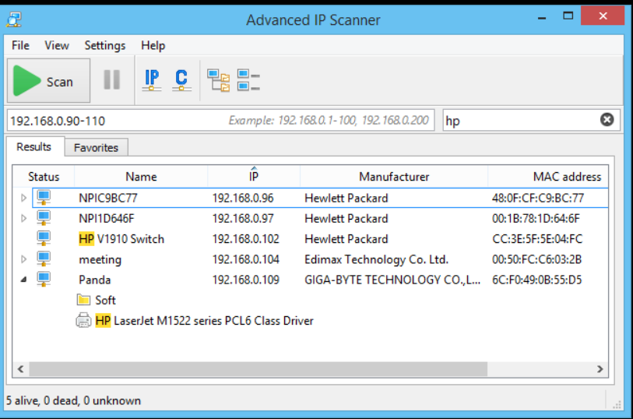

3. Advanced IP Scanner

📖 Description
Advanced IP Scanner is a user-friendly tool designed mainly for Windows to scan local networks and identify connected devices.

💻 Supported Platforms
- Windows (Primary)
- macOS (via alternatives)

⚙️ Key Features
- Detects devices (PCs, routers, printers)
- Shows shared folders and network resources
- Remote access (RDP, FTP)

🎓 Classroom Use
- Demonstrate real devices connected to WiFi/LAN
- Helps students visualize network structure
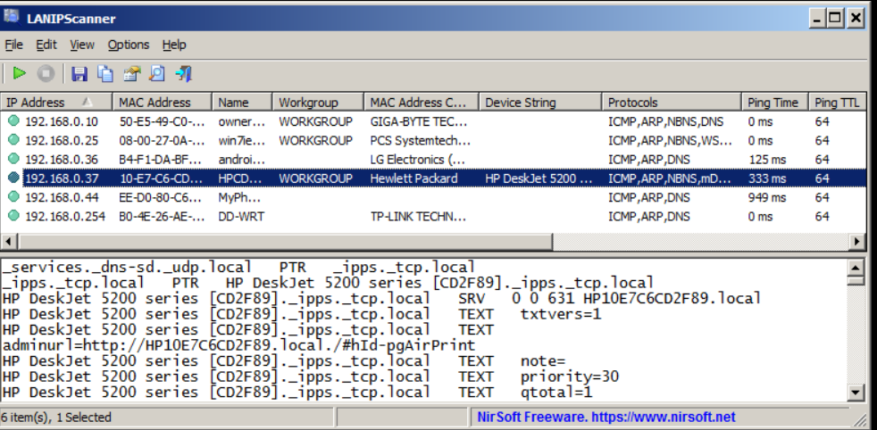
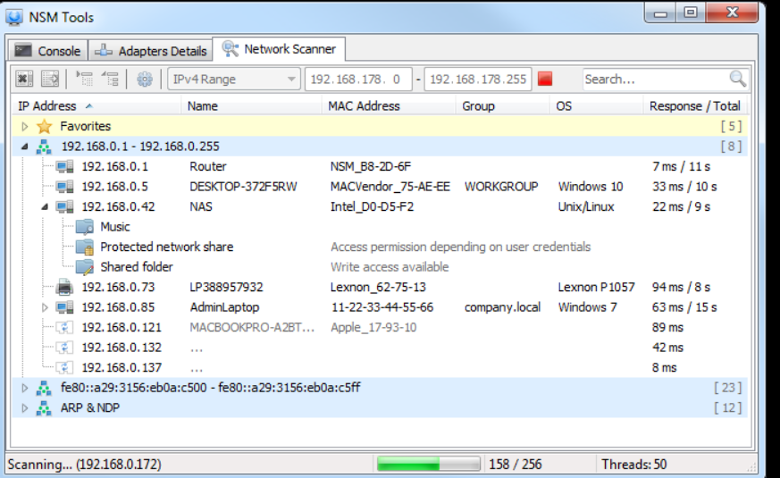

4. NetScanTools

📖 Description
NetScanTools is a comprehensive network analysis tool used for troubleshooting, monitoring, and scanning networks.
According to CEH material, it helps in discovering devices and gathering information such as IP addresses, ports, and DNS details .

💻 Supported Platforms
- Windows (Main)
- Limited macOS support

⚙️ Key Features
- Active and passive scanning
- DNS and network diagnostics
- Multi-tool integration
